**EXERCISE MONITORING SYSTEM**

**(Flutter, React, Android)**



By

**RAHEEL AFZAL (2019-ARID-3076)**

**BILAL HASSAN (2019-ARID-3018)**

**ADNAN NOOR (2017-ARID-3568)**

**Bachelor of Science of Information Technology**

**(BSCS)**

**Barani Institute of Information Technology**

**PMAS Arid Agriculture University Rawalpindi**

**Fall 2022**

**EXERCISE MONITORING SYSTEM**

**(Flutter, React, Android)**



A report submitted in partial fulfillment

of the Requirements of the degree of

**Bachelors of Computer Science**

Submitted By

**RAHEEL AFZAL (2019-ARID-3076)**

**BILAL HASSAN (2019-ARID-3018)**

**ADNAN NOOR (2017-ARID-3568)**

Supervised By

**Dr. Hassan**

**Barani Institute of Information Technology**

**PMAS Arid Agriculture University Rawalpindi**

**Fall 2022**

# **CERTIFCATE**

It is certified that the content and forms of thesis entitled **“EXERCISE MONITORING SYSTEM”** submitted by **Raheel Afzal**, **Bilal Hassan** and **Adnan Noor** have been found satisfactory forth requirements of the degree.

**SUPERVISORY COMMITTEE**

**PROJECT SUPERVISOR**

**REPORT CORDINATOR**

**WRITEUP COMMITTEE HEAD**

# **ACKNOWLEDGEMENT**

First of all, I owe gratitude to Almighty Allah the most merciful, compassionate and beneficial whose favor made it possible for me to accomplish this project. His guidance and blessings have always a source and encouragement for me and has gifted me with the unusual opportunities to reach up to this mile stone. I pay my heartiest tribute to my supervisor **Dr. Hassan** for valuable suggestions, criticism and guidance. Without that it would been impossible for me to accomplish this project successfully.

However, to the persons I give deeper and heartfelt gratitude are my teachers. No acknowledgement could ever adequately express my obligation to my friends who distinctly helped me in all aspects of this work. I owe cordial thanks for their untiring help and good company.

Finally, I am grateful to my parents who prayed for me, encouraged and supported me all the way.

May ALLAH bless all these people (Ameen)

# **Abstract**

An exercise monitoring system is designed to help users track their physical activity and ensure that they are performing exercises correctly. The system provides real-time feedback on the form and technique of each exercise, allowing users to make adjustments as needed to avoid injury and optimize their workout. By using sensors and machine learning algorithms, the system can accurately determine whether the user is executing an exercise correctly and provide personalized recommendations for improvement. The system also allows users to set and track fitness goals, providing a comprehensive solution for improving overall health and wellness.

# **Table of Contents**

**Contents Page No.**

CERTIFCATE ii

ACKNOWLEDGEMENT iii

Abstract iv

Table of Contents v

Chapter 1 1

Introduction 1

**1.1 Introductory Background** 1

**1.2 Problem Statement** 2

**1.3 Proposed Solution** 3

**1.4 Objectives** 4

**1.5 Scope** 5

CHAPTER 2 6

PROJECT BACKGROUND 6

**2.1 Related Projects and Research Articles** 6

**2.2 Old Related Projects in Market and Their Screenshots** 7

CHAPTER 3 14

CONCEPTUAL DESIGN 14

**3.1 Requirement Elicitation** 14

**3.2 Requirement Specifications** 14

**3.2.1 Functional Requirement** 14

**3.2.2 Non-Functional Requirements** 15

**3.2.3 Domain Requirements** 15

**3.3 Requirement Modeling** 15

**3.3.1 Data Flow Diagram** 16

**3.3.2 Use Case Diagram** 17

**3.4 Entity Relation Diagram** 18

Chapter 4 20

IMPLEMENTATION 20

**4.1 Tools & Technologies** 20

**4.2 Pseudo Code** 20

**4.3 Graphical User Interface** 22

CHAPTER 5 30

CONCLUSION 30

**5.1 Concluding Remarks** 30

**5.2 Future Directions** 30

**5.3 Limitations** 30

# **Chapter 1**

# **Introduction**

This chapter gives us information about application having its introductory background which contains what the application is all about its history and research related to it. Afterwards, problem statement, scope and objectives will elaborate that what is the scope of application and purpose of developing this application.

## **1.1 Introductory Background**

Life is full of science and knowledge produced by the minds of men, The god has given all these minds of inspirations, sciences and the rule, where the science is the light of life, and you know the rights of the creator, and how to communicate with users of the community in the field of engineering, medicine, modern technology and etc. As a modern health and fitness approach, health and fitness contribute many benefits.

Exercises is of great help to human health, and exercise load monitoring is also to ensure the physical and mental health of athletes. Exercise is physical activity that is planned, structured, and repetitive for the purpose of conditioning the body. Exercise consists of cardiovascular conditioning, strength and resistance training, and flexibility.

With the rapid development of our country's economy and the advent of the information age, are full of desire to care about their health. Physical exercise has become people’s pursuit of a healthy lifestyle, achieving a healthy, happy, and peaceful life, which has become a common habit for sports enthusiasts. The state advocates the use of electronic technology products to promote the development of full-product physical exercise, so that scientific and technological products serve the entire people's physical exercise.

Health concerns have gotten increased attention as a result of fast changes in many contemporary residents' lives, such as nutrition, job, sleep, entertainment, and social contact, as well as population ageing, environmental changes, and growing pressure. Physical activity is not only a reflection of the human body's fundamental functions but also, a vital approach to enhance health. Some diseases such as Parkinson's syndrome can cause sports function damage.

Patients with chronic diseases such as must maintain physical proper exercise every day to assist treatment. The elderly needs physical exercise testing and exercise testing to report unexpected conditions, and athletes need physical exercise monitoring and guidance training.

Exercise monitoring is very important for personal health monitoring and health management. Obtain the physical exercise monitoring data of the human, provide exercise services based on this, and remind to adjust their lifestyles to better realize their own health management.

Many people want to do exercise in their homes and they want to become physically

fit. But due to lack of guidance they cannot do exercises in their homes, they had to gym fees to do perfect exercise and to fit.

The mobile applications allow users to use and view for different health and fitness services tracking and workout planning, gym workouts and build your body.

So, we are introducing an application "Exercise Monitoring System" that allows users to do exercise with proper guidance and monetarized by our application. As our application is based on monitoring. The Exercise module allows the app users to measure their level of understanding of the lessons from exercise module by practically performing exercise.

Using mobile technologies, we to make the operation of information share

more efficient by saving time and communicate faster, this application will help

many people to answer their questions, development of knowledge, and separate

cultures.

## **1.2 Problem Statement**

In the modern era there has been increasing amount of interest in physical fitness and health with the most people, there are who have a full desire for that, but it may force them time or place conditions on the sometimes unsteadiness on specific date for the exercise.

Based on that project provided a mobile application for the exercise of fitness in every place at any time, thus facilitated a lot trouble discipline on a specific place or a specific time in the day and helped them to calculate calories that are burned through exercises and eat healthy food.

Many people want to do exercise in their homes and they want to become physically fit. But due to lack of guidance they cannot do exercises in their homes. They had to pay gym fees to do perfect exercise and to become fit.

People with having high prevalence of physical inactivity and high rates of preventable health conditions, including Obesity and cardiovascular now a days is common. Due to unawareness of performing exercises people are exercises in wrong way that in muscles pain and they are getting physically inactive instead of being fit.

Increased participation in fitness and wellness activities can improve their overall health and well-being. However, many fitness and wellness organizations do know how to effectively serve this population nor how to support their inclusion into their programs.

Most of the users have to use multiple apps to track their activity, do workout, exercises and meal planning. People lose interest after a while as they find it very cumbersome to use different apps and keep track of it.

## **1.3 Proposed Solution**

In recent years, with the maturity of mobile internet technology, medical technology has emerged, and a large of medical application have emerged in domestic and international markets. Exercise monitoring is very important for personal health monitoring and health management. Obtain the physical exercise monitoring data of the human body, provide corresponding exercise services based on this, and remind people to adjust their lifestyles to realize them own health management.

"Exercise Monitoring System" that allows users to do exercise with guidance and monetarized by our application. As our application is based on The Exercise module allows the app users to measure their level of understanding of the lessons from exercise module by practically performing exercise.

"Exercise Monitoring System" contains powerful fitness routine planning and tracking tools that help you target your workouts and keep easy track of your progress. Plan a routine where you can build whole workouts around individual body parts, if you like before you hit the gym.

"Exercise Monitoring System" is to evaluate the physical state of the individual through continuous monitoring. The exercise intensity is widely used in vital signs monitoring, fitness and health services, and other fields. It is widely used in vital sign monitoring, fitness and health services, and other fields.

In everyday life, the physical exercise monitoring system for individual or family users must monitor the essential exercise parameters in the simplest manner simplest in order to analyses the physical activity pattern and the user's health state.

"Exercise Monitoring System" is an implementation of monitoring exercises which is to monitor users with the help of backend wireframe which stored in database then that backend wireframe will check the exercise of users by comparing it with backend wireframe. In this way we will monitor exercises. The mobile applications allow users to use and view for different health and fitness services tracking and workout planning, gym workouts and build your body.

This is designed to facilitate a gym and fitness center to automate its operations of keeping records and store them in form of a large and user-friendly further easy access to the

## **1.4 Objectives**

The core objectives and aim of EXERCISE MONITORING SYSTEM is to following:

* To perform exercises under monitoring.
* To resolve the problem of inaccurate exercises.
* To home accessible exercise plan.
* To provide a trainer free environment to users.
* To reduce the chances of redundancy in application.
* To improve physical health and achieve fitness goals.

## **1.5 Scope**

The health and fitness industry have become extremely diverse in the range of services and facilities it offers; varying from large scale leisure centers and Gymnesians, to individual personal trainers who travel from one client to the next in their cars. Some services specialize in offering structured classes, others are informal; some cater for a particular demographic, and others for anyone.

Many issues avoiding individuals from becoming more energetic and following health care commendations are a gradually busy life style and the deficiency of inspiration, physical activity and accessible direction. Though the use of private trainers rises in people, they are often costly and must be planned in advance.

In this research "Exercise Monitoring System" is designed to provide quality service to users and to provide them trainer free exercise environment. This system requires database to store exercise related data. This application involves almost all the features of monitoring the exercises.

The record of exercise data agrees consumers to track their performance, observe progresses and relate it with their aims and performance of other operators, which growths enthusiasm. This application is basically for fitness freaks and patients. To use this application user must have some knowledge of Android and IOS. The future implementation will be online help for users through live sessions from trainers.

# **CHAPTER 2**

# **PROJECT BACKGROUND**

This chapter contains discussion about related projects made in past including them designing phase and the way they operate. It includes all old related projects that are developed in BIIT and running in market.

## **2.1 Related Projects and Research Articles**

This is a project named "GYM EXERCISE TRAINER" which was developed by "Aneesa bibi" and Syed Zeeshan Ali Naqvi last years. The basic functionality of this application was a monitor exercise that is using for instructing the users to perform exercise in proper way.

I have updated the functionality to make it more useful and easier to use. The basic functionality of this application is to monitor users. By this functionality users can exercise accurately and there are minimum chances of users to become unfit by performing exercises. By generating results users can check their performance. Another functionality of this application is that it works rapidly as there is live detection. This application is specifically focusing on monitoring.

In "GYM EXERCISE TRAINER" the result generated after the performing exercise and there was no live detection for users to perform exercise and also there was no proper monitoring that can check users whether they performed exercises accurately or not. I have added up all these new functionalities which includes live detection and monitoring exercises.

## **2.2 Old Related Projects in Market and Their Screenshots**

The basic functionality of old application is to monitor users. By this functionality users can exercise accurately. By generating results users can check their performance.

There are some problems in this application these are given below:

* It does not tell users on runtime about their mistakes
* It saves result after the performing exercise which users does not know if they should correct their posture or not.
* By not knowing on the runtime that exercise is performing correctly or not, users may have face physically injuries.
* There are only few Exercises.
* It is not user friendly.



Figure ‎0.1 Splash Screen

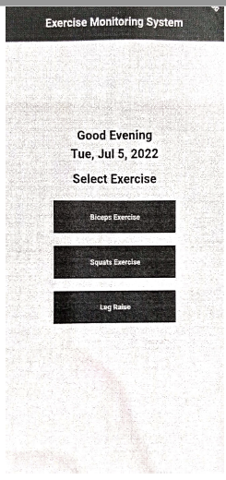

Figure ‎0.2 Select Exercise

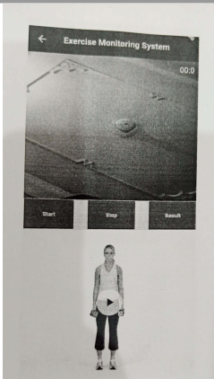

Figure ‎0.3 Exercise Monitor

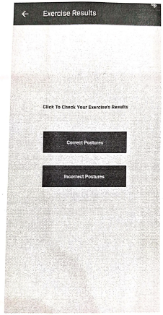

Figure ‎0.4 Result Option

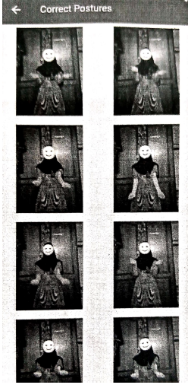

Figure ‎0.5 Correct Posture

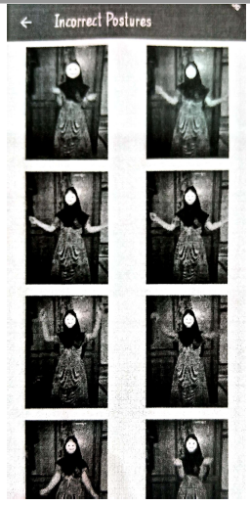

Figure ‎0.6 Incorrect Posture

# **CHAPTER 3**

# **CONCEPTUAL DESIGN**

This chapter gives us information about requirements of application which contains what will be functionality of application. Afterwards, Data Flow Diagram (DFD), Use Case Diagram, Entity Relationship Diagram (ERD) and Conceptual Diagram which will elaborate the flow of application.

## **3.1 Requirement Elicitation**

Requirement Elicitation is basically the source of gathering requirements. We have gathered requirements from a gym named "Stone age GYM". We meet the trainer and asked different questions about the way of performing exercises. We also gathered requirements through observation from visiting different gyms. We observe that people were not doing exercises properly, even the instructor was guiding them.

## **3.2 Requirement Specifications**

Requirement Specification describes what the software will do and how it will be expected to perform. In this application we are on monitoring the exercises and properly giving guidance to users to perform their exercises in proper way without going to gym. This application is providing ease to users that users can perform exercise at any time from home, when they get free from their busy routine.

### **3.2.1 Functional Requirement**

Functional Requirements of this project are as follows:

* User views different types of exercises i.e., shoulder exercises, legs exercises, arm exercises etc.
* User can select exercises from menu.
* User can first watch the video given by instructor with the whole instructions.
* User Will perform the following exercise from which they have and their mobile camera monitor the whole exercise.

### **3.2.2 Non-Functional Requirements**

The interfaces of this application are simple and user friendly, as camera automatically for detection of exercises. So, the application is easy to use of its interactive design. This application is also secure because there is no risk to user's data. The of this application is very good and fast as it monitors exercises quickly and generate accurate results.

### **3.2.3 Domain Requirements**

It is the requirement that comes from the application domain of the system that reflects the characteristics of that domain. The domain of this application is users must have some knowledge of Android and IOS. This application is basically for fitness freaks and for patients. This application is for live detection of exercises.

## **3.3 Requirement Modeling**

Following are the modelling of the requirements in the form of Data Flow Diagram (DFD) and Use Case Diagram so a technical can judge the application.

### **3.3.1 Data Flow Diagram**

Data flow diagram represents the flow of data system and entities. As described below how our application can communicate with system and which tasks are performed by the User.

**Level 0**

0

Request

Select Exercise

Perform exercise

Show Result

1.4

Response

Request

perform

played

watch

Selected

YYYYYYYY

Exercise Monitoring System

E

Trainer Exercise Points

1.3

Perform and Transform

1.2

1.1

Exercise Video

Select Exercise

1.0

user

Response

Perform Exercise

YYYYYYYY

Exercise Monitoring System

E

user

**Level 1**

### **3.3.2 Use Case Diagram**

Data flow diagram represents the flow of data system and entities. As described below how our application can communicate with system and which tasks are performed by the User.



**User**

Exercise Monitoring System

## **3.4 Entity Relation Diagram**

An entity–relationship model (or ER model) describes interrelated things of interest in a specific domain of knowledge. A basic ER model is composed of entity types (which classify the things of interest) and specifies relationships that can exist between [entities](https://en.wiktionary.org/wiki/entity) (instances of those entity types).

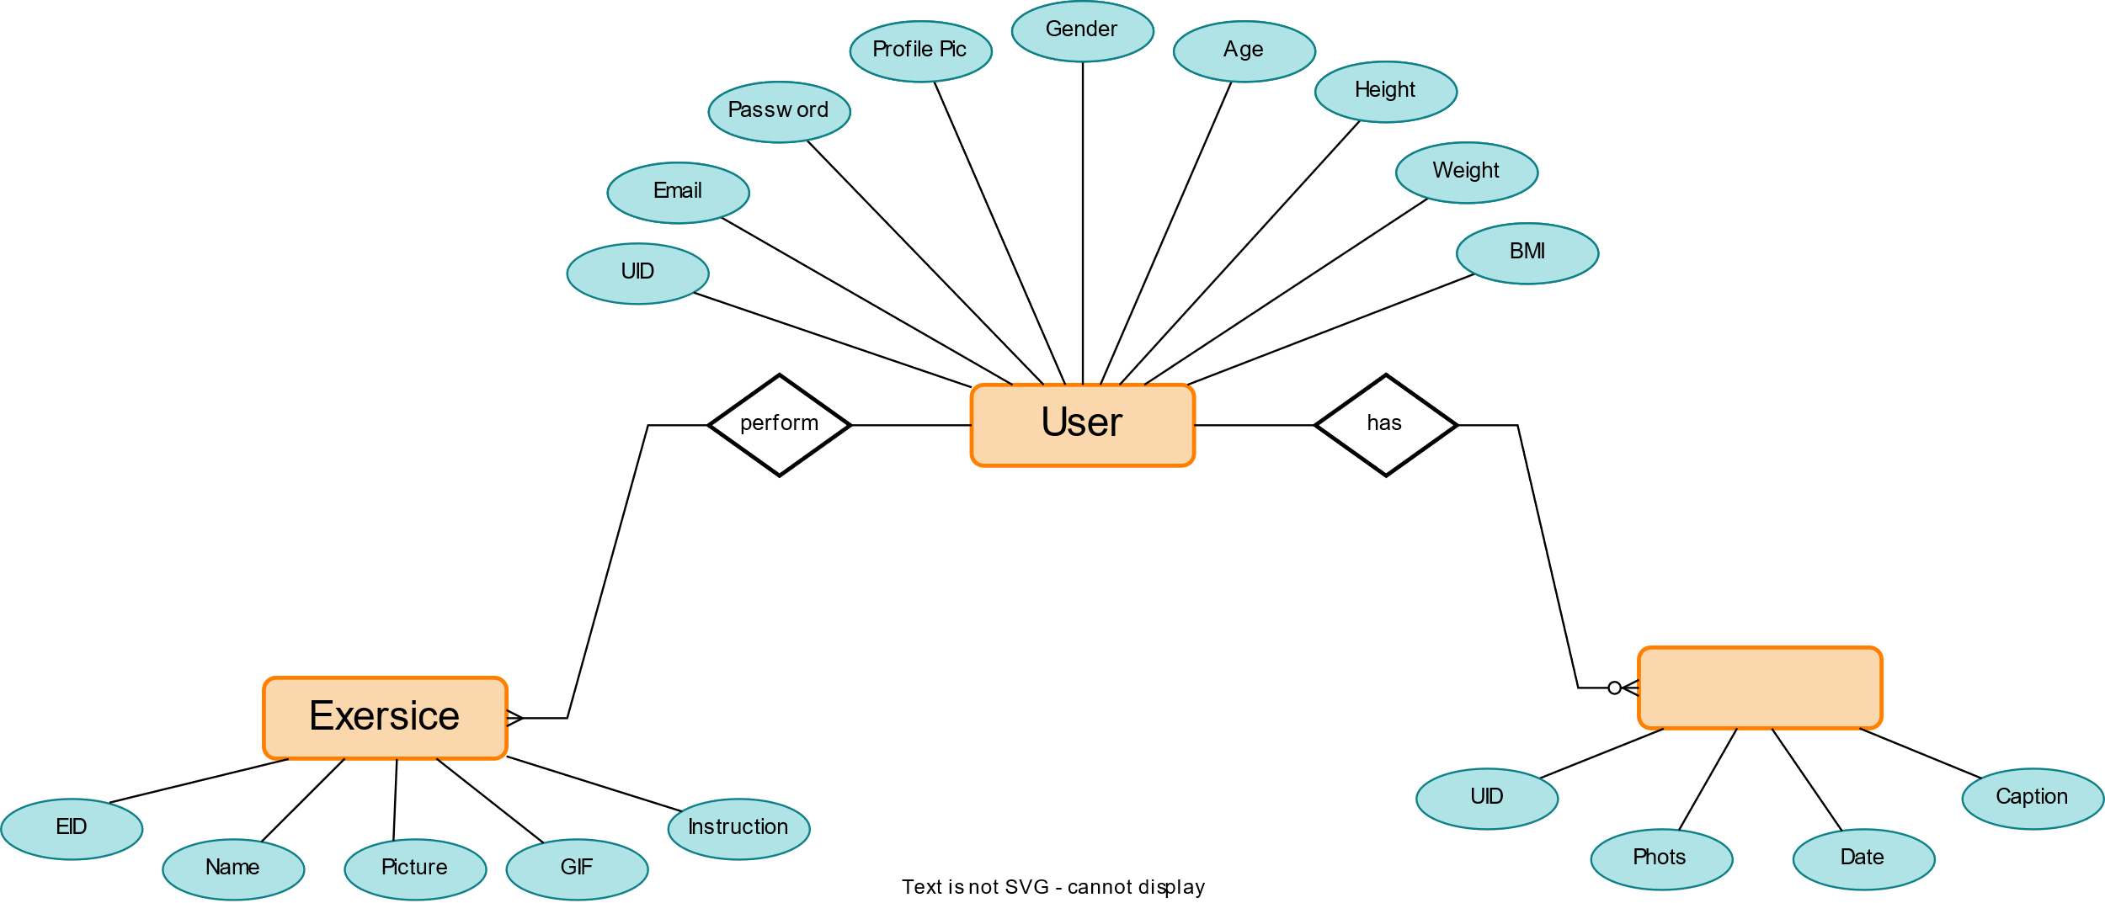

Progress Pics

Progress Pics

**3.5 Software Process Model**

The software process model we are using for this project is Incremental model due

to the following reasons:

• Our requirements of the system are clearly defined and understood which

are given to us from our supervisor.

• Our requirements are prioritized which are to be made first.

• Our project is made through step-by-step using software life cycle to

make sure that our project is progressing

• High risk factors are involved in our project e.g., we need to monitor

exercises to make sure that exercises are done with guidance.

# **Chapter 4**

# **IMPLEMENTATION**

This chapter gives us information about Tools and Technologies which have used for of this application. It also includes how the application has designed through coding. Also, this chapter includes the discussion about graphical user interface and this can show through project shots.

## **4.1 Tools & Technologies**

Following is the list of Tools and Technologies which is used to develop this application. It includes development languages, and information.

**For Mobile App**

* VS Code
* Metro Server
* Android Studio

**For Web API**

* python FAST Web API
* PyCharm Professional Edition 2022.3.1

## **4.2 Pseudo Code**

**Check Biceps Exercise Angle Pseudo code**

If (160 > Left Elbow Angle < and 160 > Right Elbow Angle < 30)

Then Exercise is in correct

Exercise is Incorrect

**Check Squats Exercise Angle Pseudo code**

If (160 > Left Knee Angle < 120 and 160 > Right Knee Angle < 120)

Then Exercise is Correct

Else Exercise is Incorrect

**Check Leg Raise Exercise Angle Pseudo code**

If (75 > Left Hip Angle < 20 and 75 > Right Hip Angle < 20)

Then Exercise is correct

Else Exercise is Incorrect

**Check Correct Result Exercise Pseudo code**

If (Correct Images O)

Then Exercise Result Not Found

Else Show Result of Correct Exercise

**Check Incorrect Result Exercise Pseudo code**

If (Incorrect Images 0)

Then Exercise Result Not Found

Else Show Result of Incorrect Exercise

## **4.3 Graphical User Interface**

Figure ‎0.1 Onboard Screen

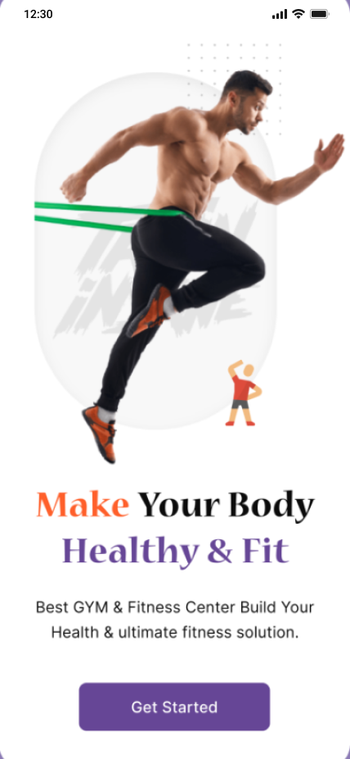

Figure ‎0.2 splash screen



Figure ‎0.3 login

Figure ‎0.4 sign Up



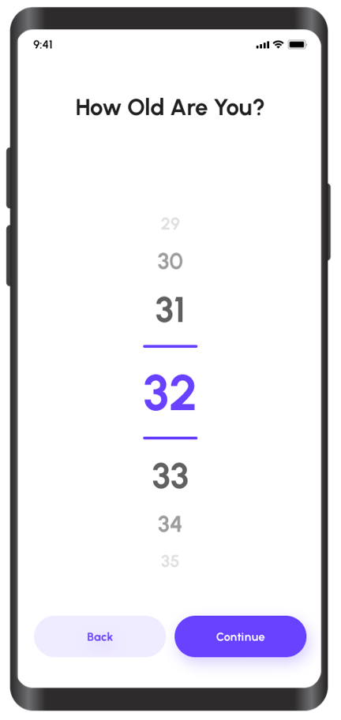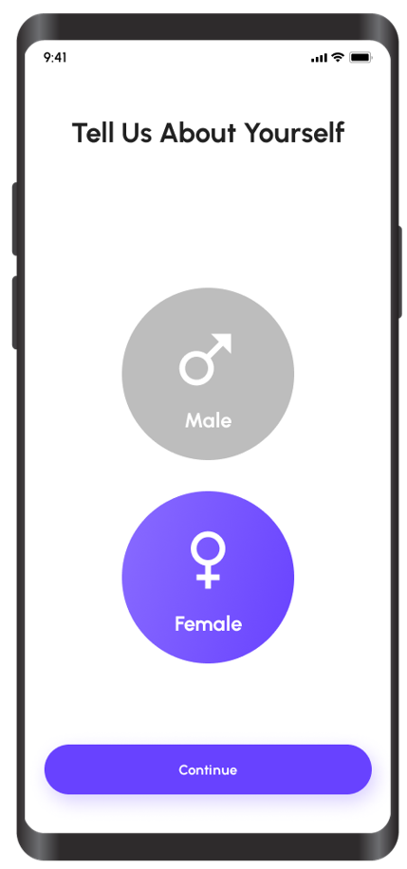

Figure ‎0.5 Select Age

Figure ‎0.6 select Gender

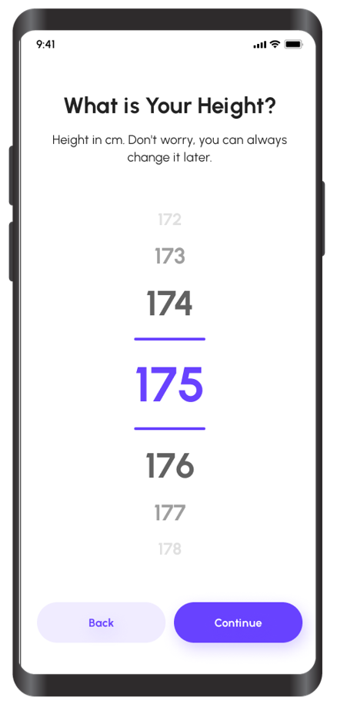

Figure ‎0.7 Select height

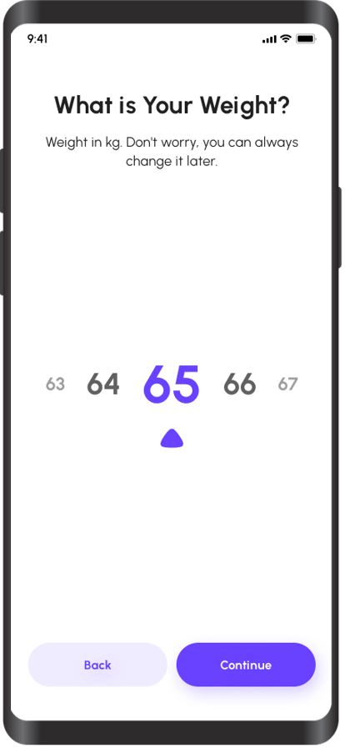

Figure ‎0.8 Select Weight



Figure ‎0.9 Exercise Instruction

Figure ‎0.10 Exercises Screen



Figure ‎0.11 Monitor Exercise Screen



Figure ‎0.12 Edit Profile Details

Figure ‎0.13 profile Detail

# **CHAPTER 5**

# **CONCLUSION**

## **5.1 Concluding Remarks**

This project is successfully completed and met the requirements and objectives. The application covers all the major modules which are used to fulfill the requirements and facilities and also provide effective and efficient platform for user to improve their exercise. "Exercise Monitoring System" is a software solution for the user to improve their way of performing exercise who wants to have trainer free environment. This app provide facility for user to maintain their fitness in accurate and appropriate way and to make sure that user will get guidance about their exercises.

## **5.2 Future Directions**

For further future work in "Exercise Monitoring System" is to application version for more ease and up going time with advance technology. In future "Exercise Monitoring System" will be updated along with new and latest features like add, update and delete the record of user exercises along with the ability to check multiple users for guidance as it is only handling single user at a time at this moment. Proper feedbacks systematically taken from various users and organizations over interface and their desired work platform to further improve this application according to market and user needs.

## **5.3 Limitations**

The application is on React devices and the other thing that user must having an Internet connection and also this application can only handle one user at the time. Although it's not that much noticeable for now but with time and evolution in technology so it will be much improvement can be done in this application.